**2016 Leaving Cert Physics Solutions (Ordinary Level)**

**2016 no.1**

1. **Draw a labelled diagram of the arrangement of the apparatus used in this experiment.**

Labelled diagram to show:

2 trolleys

Runway

Timer e.g. tickertape (and timer)

Means of trolleys joining

Detail e.g. sloped runway, means of measuring mass / time / distance

1. **How was mass measured?**

Used an electronic balance

1. **What measurements were taken to calculate velocity?**

Relevant distance specified

Relevant time specified

1. **How were these measurements used to calculate velocity?**

Velocity = distance / time

1. **How did the student determine the momentum?**

Momentum = (mass)(velocity)

1. **How did the student verify the principle of conservation of momentum?**

Momentum before = momentum after

m1u1 + m2u2 = m1v1 + m2v2

**2016 no.2**

1. **Draw a labelled diagram of the arrangement of the apparatus used in this experiment.**

Labelled diagram to show:

Glass/plastic block

Ray box /

Detail e.g. protractor // metre stick / mirror

1. **Indicate on your diagram the measurements that were taken.**

Angle of incidence

Angle of refraction

1. **What instrument was used to take these measurements?**

Protractor // metre stick / ruler

1. **How was the refractive index calculated?**

n = sin i/sin r

1. **Why should the experiment be repeated?**

For increased accuracy / to get average / to draw a graph

**2016 no.3**

1. **Draw a labelled diagram of the arrangement of the apparatus used in this experiment.**

Labelled diagram to show:

Resonance tube

Tuning fork / signal generator

Means of measuring length e.g. ruler / metre stick / means of changing length

Detail e.g. fork over the mouth of tube

1. **How did the student find the frequency of the sound wave used?**

Read it from the tuning fork / signal generator

1. **What other measurements did the student take?**

Measure length of vibrating air

Measure diameter of tube

1. **How did the student calculate the speed of sound in air?**

c = 4f (l+0.3d)

1. **State one precaution which the student might have taken to get an accurate result.**

Use a vernier callipers to find the diameter of the tube, quiet background,

Use a tuning fork of high frequency as it is easier to hear, avoid no parallax,

**2016 no.4**

1. **Draw a labelled diagram of the arrangement of the apparatus used in this experiment.**

Ammeter / multimeter, heating coil, calorimeter

Variable power supply

Detail e.g. closed circuit, stop watch, insulation, variable resistance, thermometer

1. **How was the current changed during the experiment?**

Adjust the (variable) power supply / (variable) resistor

1. **Copy the table below and complete it in your answerbook.**

|  |  |  |  |  |  |  |  |
| --- | --- | --- | --- | --- | --- | --- | --- |
| *I* (A) | 1.0 | 1.5 | 2.0 | 2.5 | 3.0 | 3.5 | 4.0 |
| *I*2 (A2) | 1 | 2.25 | 4 | 6.25 | 9 | 12.25 | 16 |
| ***Δθ*** (0C) | 2.3 | 4.9 | 8.8 | 13.0 | 20.2 | 26.0 | 35.2 |

1. **Using the data in the completed table, draw a graph on graph paper of Δθ against I2.**

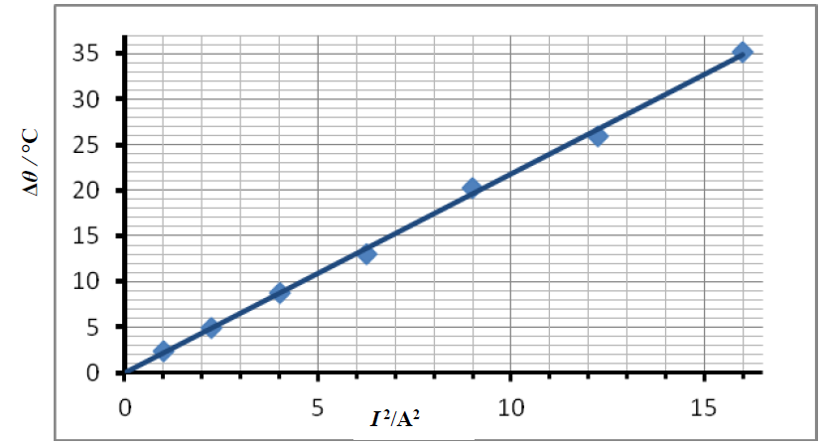

1. **Explain how your graph verifies Joule’s law.**

Straight line through origin shows that Δ*θ* α *I*2 / P α *I*2

**2016 no.5**

1. **State the principle of Archimedes.**

When a body is immersed in a liquid the upthrust is equal to the weight of the displaced liquid

1. **A tractor applies a force of 500 N to pull a trailer a distance of 3 km.   
   Calculate the work done by the tractor.**

W = Fs = 500 × 3000 = 1.5 × 106 J

1. **Choose from the list below the instrument used to measure (i) pressure, and (ii) energy.**

(*i*) barometer (*ii*) joulemeter

1. **State two uses for a concave mirror.**

Headlights, makeup, shaving mirrors, etc.

1. **Conduction is one method of heat transfer. Name the other two methods.**

Convection, radiation

1. **What is the function of a lightning conductor?**

To earth / protect building / safety /

1. **There are 150 turns in the primary coil of a transformer and 3000 turns in the secondary coil.   
   Calculate the output voltage when 12 V a.c. is connected across the primary coil.**



*Vs* = voltage across the secondary coil, *Vp* = voltage across the primary coil

*Ns* = Number of turns in secondary, *Np* = Number of turns in primary coil



$$V_{s}=\frac{N_{s}}{N_{p}}V_{p}$$

$$V_{s}=\frac{3000}{150}(12)= 240 V$$

1. **State one common use of the electroscope.**

Test for charge, identify charge, measure potential etc.

1. **What is the photoelectric effect?**

Emission of electrons from the surface of a metal when light (radiation) of the correct frequency is incident on it.

1. **What are alpha-particles?**

Helium nucleus / two protons and two neutrons

**2016 no.6**

1. **Define the term force and state the unit of force.**

Force is anything that can cause an object to accelerate

1. **Name another example of a vector quantity.**

Displacement, velocity, acceleration, etc.

1. **State the factors which affect the size of the gravitational force between two bodies.**

Mass of first body

Mass of second body

Distance

1. **Calculate *g*, the acceleration due to gravity on the surface of Pluto.**

= 0.62 m s-2

1. **Calculate the weight it would have on the surface of Pluto.**

Weight = mg = 450 × 0.62 = 279 N

1. **Would you expect its weight at this position to be greater or less than it would be at the surface?   
   Explain your answer.**

Less

Further away (from Pluto)

1. **Explain why Pluto’s atmosphere exerts a very low pressure on its surface.**

The gravitational force of attraction is much smaller, Pluto has a small mass (relative to the earth), etc.

1. **Suggest a reason why solar panels were unsuitable in this case.**

Pluto is too far from the sun, they wouldn’t generate much energy

**2016 Question 7**

1. **Explain the underlined terms.**

Longitudinal waves: the vibration (of the medium) is in the same direction of motionof the wave.

Transverse waves: the vibration (of the medium) is perpendicular to the direction of motionof the wave

1. **Describe a laboratory experiment which demonstrates that sound requires a medium to travel through.**

Apparatus: bell jar, electric bell / phone, battery, vacuum pump

Procedure: turn on pump / remove the air

Observation/conclusion: no sound heard when air removed, so sound needs a medium

1. **With the aid of a labelled diagram, explain how total internal reflection occurs.**

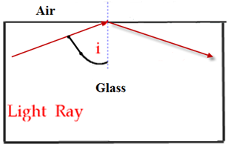If the angle of incidence is increased beyond the critical angle, the light ray won’t leave the block, but will ‘reflect’ back as if it was striking the surface of a mirror.   
We say that the light is now ‘totally internally reflected’.

1. **State two uses of optical fibres.**

Telecommunications, endoscope, correct specific ornament/toy, to supply light to inaccessible places, etc.

1. **Calculate the minimum angle at which light can strike the sides of the fibre and still be transmitted through the fibre.**

n = 1.44

$$n=\frac{1}{sin C}$$

$$\sin{C}=\frac{1}{n}$$

$$\sin{C}=\frac{1}{1.44}$$

sin C = 0.694

C =

C = 43.980

1. **What is the unit of sound intensity level?**

Bel / B // decibel / dB

1. **Why might a sound-level meter be used in a workplace?**

To ensure the sound level is below (permitted) limit

**2016 Question 8**

1. **Define voltage**

Potential energy between two points on a circuit / potential difference / ***W/Q*** / electromotive force

1. **Define resistance.**

The ratio of the potential difference to the current / ***V/I***

1. **Name an instrument used to measure each of these quantities.**

Voltmeter / multimeter

Ohmmeter / multimeter

1. **Name a source of voltage.**

Battery / cell /power supply /generator / thermocouple / solar panel

1. **Calculate the total resistance of the circuit $$\frac{1}{R_{Total}}= \frac{1}{R_{1}}+ \frac{1}{R_{2}}$$**

$$\frac{1}{R_{Total}}= \frac{1}{4}+ \frac{1}{4} =\frac{1}{2}$$

R = 2 Ω

1. **Calculate the current flowing through the ammeter**
$$I=\frac{V}{R}=\frac{12}{2}=6 Amps$$

2. **Calculate the current flowing through each resistor.**

The 4 Ω resistors are in parallel with the 12 V supply, so the voltage is the same (12 V).

= 3 Amp

I2 is also 3 Amps

1. **One effect of an electric current is the heating effect.   
   Name the two other effects of an electric current.**

Chemical

Magnetic



1. **Describe an experiment to demonstrate one of these two effects.**

**Chemical**

e.g. electrolysis

Observation: gas is produced in both test tubes

**Magnetic**

Apparatus: power supply with circuit, plotting compass

Procedure: turn on the current

Observation: compass direction changes.

**2016 Question 9**

1. **What is meant by latent heat?**

Latent heat is the heat energy required to change the state of a substance (without changing temperature)

1. **Name an instrument used to measure temperature.**

Thermometer

1. **Calculate the energy removed from the water to reduce its temperature to 0C**

E = mcΔθ

= 0.75 × 4200 × 20

= 63000 J

1. **Calculate the energy removed from the water to convert the water at 0C to ice at 0C**

E = ml

= 0.75 × (3.3 × 105)

= 247500 J

1. **Calculate the energy removed from the water to cool the ice at 0C to ice at −15 0C.**

E = mcΔθ

= 0.75 × 2200 × 15

= 24750 J

1. **How long will it take for the freezer to remove 9000 J of energy from the water?**

$P=\frac{Work}{time}$ $time=\frac{Work}{power}$ $time=\frac{9000}{300}$ time = 30 s

1. **As the water freezes, the glass bottle cracks and shatters. Explain why this occurs.**

The water expands (and the glass contracts).

1. **The freezer is an example of a heat pump. Outline the operation of a heat pump.**

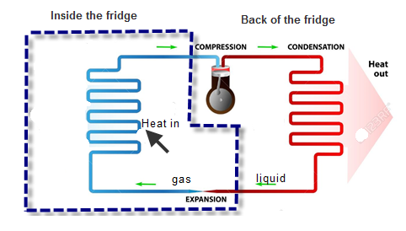The section on the left (in blue) is inside the fridge; the section on the right (in red) is at the back of the fridge

A special liquid is pumped around the pipe as shown.

In order to help to figure out how it works, note the following.

* *Inside* the blue section the liquid expands quickly, and in going from a liquid to a gas it takes in energy from around the pipe. This pipe is inside the fridge so the air in that section cools down.
* *Outside* the blue section a pump is used to compress the gas which causes it to go back into a liquid state, and in the process it gives heat energy back out to the surroundings.

**2016 Question 10**

1. **State two properties of the electron.**

(Negatively) charged, deflected by electric fields, deflected by magnetic fields, fundamental particle, small mass, outside nucleus, etc.

1. **Name another sub-atomic particle.**

Proton, neutron, quark

1. **Name the parts labelled A, B, and C in the diagram.**

A: cathode

B: anode

C: screen

1. **State the function of any two of these parts.**

Cathode emits electrons / particles

Anode attracts / focuses /accelerates (electrons)

Screen lights up / shows presence (of electrons)

1. **How could the beam of electrons be deflected?**

Electric field / electrode / magnetic field / magnet / X-Y plates

1. **Why is it important to have a vacuum inside a cathode ray tube?**

Electrons not blocked / easier to pass through / electrons not absorbed

1. **State one use of a cathode ray tube.**

Monitors, TV (screen), computer screen, etc.

1. **Draw a sketch of an X-ray tube.**

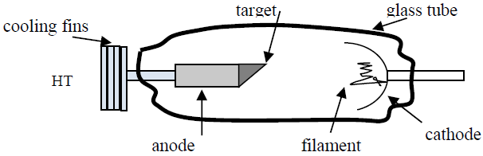

1. **Why are lead aprons often worn when using an X-ray tube?**

Protect body, safety

**2016 Question 11**

* 1. **What word is used to describe the bending of light by a prism?**

Refraction

* 1. **What does the spectrum of light consist of?**

The range of colours that make up visible light

* 1. **Which colour of light is bent the most?**

Blue (or violet)

* 1. **Draw a diagram to show how a spectrum can be produced using a prism.**

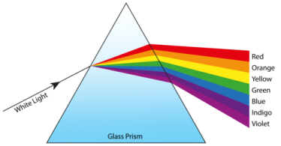

* 1. **What was the significance of Newton’s experiment?**Light is made up of different colours
  2. **Without using a prism, how else can a spectrum be produced?**Using a diffraction grating
  3. **Why is a spectrum not produced by an ordinary block of glass?**Because the light splits on entering the prism but recombines again on leaving the prism
  4. **Name another field of physics for which Newton is famous.**

Mechanics, gravity, heat

**2016 Question 12 (a)**

1. **Define *kinetic energy* and *potential energy*.**

Kinetic energy is energy an object has due to its motion.

Potential energy is the energy an object has due to its position in a force field.

1. **Calculate the potential energy of the egg before it was dropped.**

Potential energy = mgh = (0.052) (9.8) (2) = 1.02 Joules

1. **Calculate the velocity of the egg as it hit the ground.**

The potential energy of the egg at the top is equal to the kinetic energy of the egg at the bottom

mgh = ½mv2

⇒ v2 = 2gh

⇒ v2 = (2)(9.8)(2) = 39.2

⇒ v = 6.26 m s-1

1. **Suggest how the egg could be protected from breaking when it hits the ground.**

Place a soft material (e.g. balls of paper) on the ground under it to give it a soft landing, etc.

1. **State one everyday application of the principal behind the protection of the egg.**

Air bags in cars, on the ground for safety when workers are up on a height, etc.

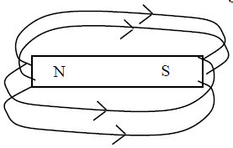**2016 Question 12 (b)**

1. **Copy the diagram and show on it the magnetic field lines around the magnet.**

See diagram

1. **Describe an experiment to plot the magnetic field lines around the magnet.**

Apparatus: magnet, (plotting) compass

Procedure:

Place the compass on the paper and mark the dot at the tip of the compass.

Repeat again and again and then join the dots to see the field lines

Observation: the lines go from north to south and the field lines are concentrated at the magnet’s poles

1. **Name a metal that is attracted to a magnet.**

Nickel, iron, cobalt, steel

1. **State two practical uses of a magnet.**

Compass, keep fridge door closed, electric bell, electric motor, transformers, electromagnets, moving coil meters, loudspeakers, etc.

**2016 Question 12 (c)**

1. **State one advantage of using of a ring circuit when wiring a house.**

Cables carry less current, fewer sockets, fewer safety devices, etc.

1. **What is meant by earthing?**

A wire connects the metal body of appliances to the earth / ground

1. **How does earthing contribute to safety?**

In the event of a fault occurring the current will flow to earth

1. **Name one other safety device used in domestic wiring.**

Fuse, circuit breaker, MCB, RCD

1. **Name the other two wires and state the colour associated with each of them.**

Neutral is blue and the earth is green-yellow

**2016 Question 12 (d)**

1. **What is meant by nuclear fusion?**

Nuclear Fusion is the combining of two small nuclei to form one large nucleus with the release of energy

1. **Name the other type of nuclear reaction used in nuclear power stations.**

Fission

1. **State one advantage and one disadvantage of each of these sources of nuclear energy.**

Fusion advantage: H and He atoms are plentiful, fusion produces lots of energy, little waste,

Fusion disadvantage: very high temperatures needed, uneconomical at present, more difficult to control and sustain, etc.

Fission advantage: (breeder reactors) can make their own fuel, can generate radioisotopes (for medicine), etc.

Fission disadvantage: dangerous raw material,

1. **Name the scientist whose equation E = mc2 explained why a large amount of energy is available from a small mass of fuel in nuclear reactions.**

Einstein